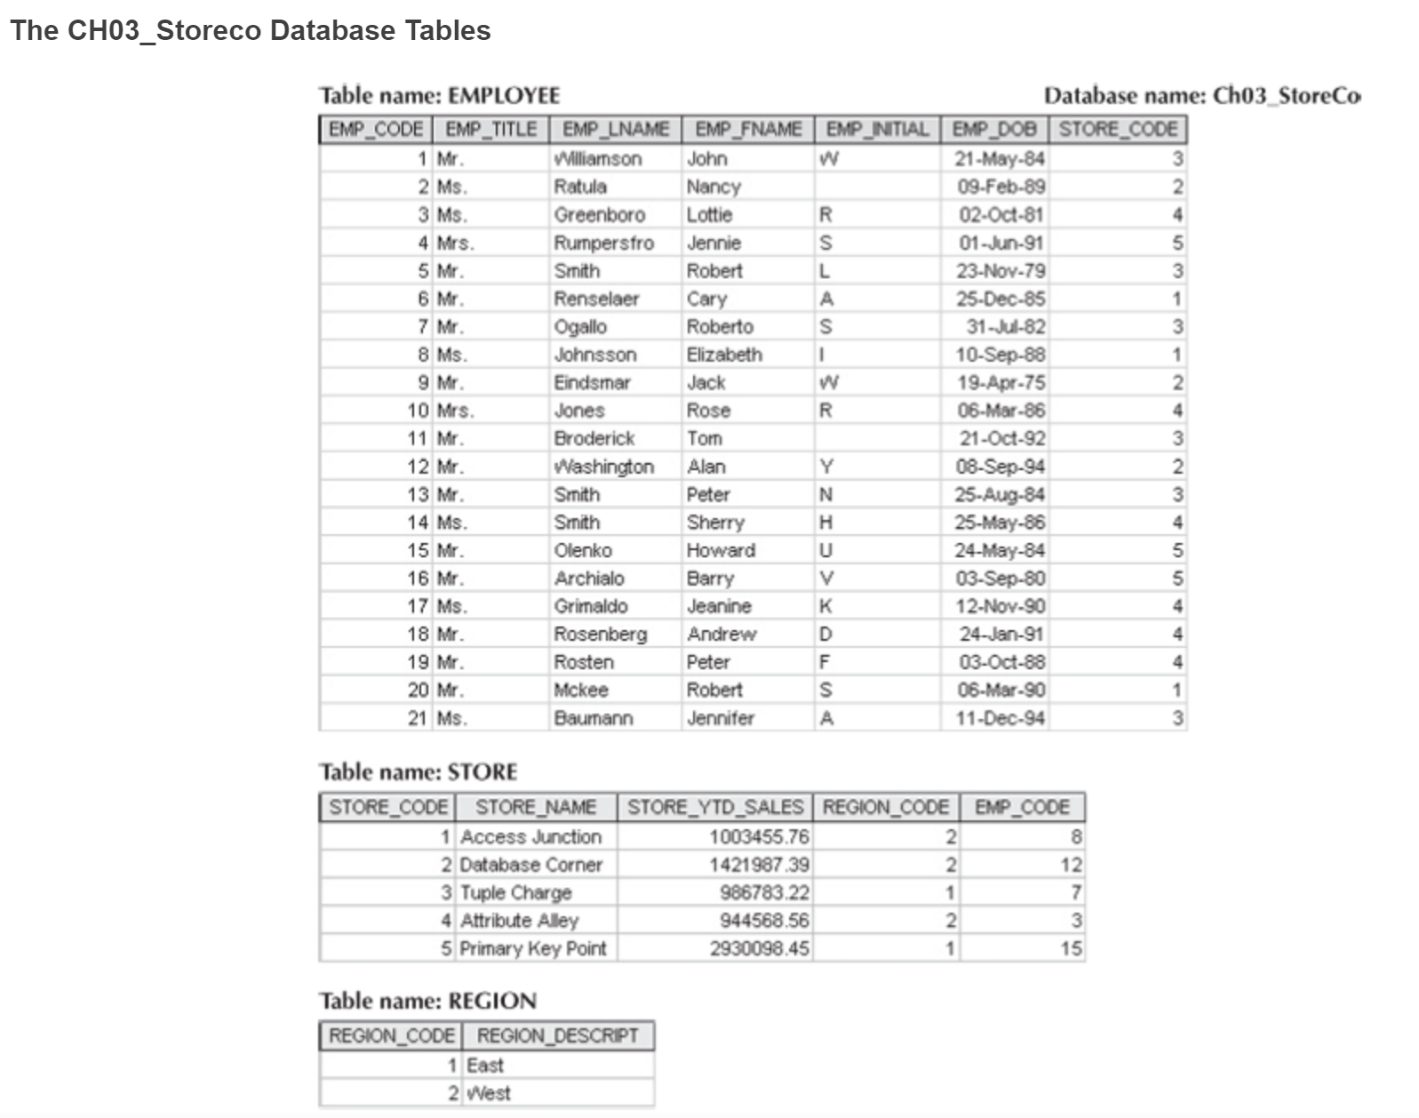

1. For each table, identify the primary key and the foreign key(s). If a table does not have a foreign key, write None.

- Yes the employee has EMP_CODE as the primary key and then its foreign key is STORE_CODE. The store has STORE_CODE as its primary key and then the foreign key is REGION_CODE & EMP_CODE. While region only has REGION_CODE for its primary but none for the foreign key.

- primary key - foreign key

EMP_CODE - STORE_CODE

STORE_CODE - REGION_CODE, EMP_CODE

REGION_CODE - NONE

1. Do the tables exhibit entity integrity? Answer yes or no, and then explain your answer.

- Yes each entity integrity of employee, store and region has a unique code value and there is no nulls.

1. Do the tables exhibit referential integrity? Answer yes or no, and then explain your answer. Write NA (Not Applicable) if the table does not have a foreign key.

- Employee is a yes for referential integrity because each EMP_CODE value in employee points to an existing STORE_CODE value in store. For store it is also a yes for referential integrity because each REGION_CODE value in store points to an existing REGION_CODE value in region and each EMP_CODE value in store points to an existing EXP_CODE in employee. However, region is a no for referential integrity because there isn’t any applicable NA for a foreign key.

1. Describe the type(s) of relationship(s) between STORE and REGION.

- The relationship between STORE and REGION is M:1 because REGION_CODE value occurs more than once in STORE, while each REGION can contain many stores.

1. Describe the type(s) of relationship(s) between EMPLOYEE and STORE. (Hint: Each store employs many employees, one of whom manages the store.)

- The relationship between EMPLOYEE and STORE is M:1 due to a store can employee many employees. However it can be a 1:1 due to one employee can manage one store so it just depends on how you look at it.

1. 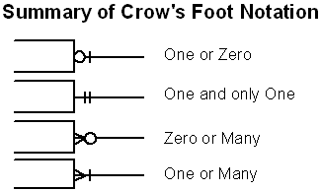Create the ERD to show the relationships among EMPLOYEE, STORE, and REGION. Use Lucid chart to create your ERD with crows foot notation. List any assumptions you make of how the business works to receive full credit! Please screenshot your ERD, paste it here, and upload this word document with your answers when you are done.

